|  |  |
| --- | --- |
| **CITY OF HARTFORD**  **2023-24 HOPWA APPLICATION** | |
| **Deadline: February 28, 2023 at 11:59PM**  Applications and instructions are available on the Central Grants website at  https://www.hartfordct.gov/Government/Departments/OMBG/Central-Grants/. | |
| **Organization (applicant) Information**  **Name:**  **Street:**  **City:**       **State:**     **Zip:**    **Federal TIN #:**        **DUNS #:** | **Organization Financial Information**  **Organization Annual Budget: $**     **__________**  **Total Cost of HOPWA Activity: $**     **__________**  **% of Organization’s Annual Budget: %**     **______**  **HOPWA Funds Requested: $**     **_____** |
| **Person Authorized To Bind Organization (CEO or Executive Director)**  **Name:**       **Title:**       **Tel:(**   **)**       **_______**  **Email:**      **________** | **Organization’s Chief Financial Officer**  **Name:**       **Title:**       **Tel:(**   **)**       **_____**  **Email:**      **_________** |
| **Please include one copy of each of the following with your application (1 point deducted for each item not submitted):**  501(c)(3) designation from the IRS  Proof of incorporation from the CT Secretary of the State  Current list of the organization’s Board of Directors  Organization’s single audit report for its most recent fiscal year (2021 or 2022); or  Organization’s financial statement for the most recent fiscal year (ending 2021 or 2022) | |

|  |  |  |  |  |
| --- | --- | --- | --- | --- |
| **CHECKLIST/COVER SHEET**  **Electronic version, of the following:**    **Completed Application**  **Sections I-VIII**  **Sections IX (Budget)**  **Attachments:**  **501(c)(3) designation from the IRS**  **Proof of incorporation from the CT Secretary of the State**  **Current list of the organization’s Board of Directors**  **Organization’s single audit report for its most recent fiscal year (2021 or 2022); or**  **Organization’s financial statement for the most recent fiscal year (2021 or 2022)**  **City of Hartford Grantee Certification and Official Signature (signed and dated)**  **City of Hartford Tax/Financial Certification and Declaration of Delinquencies (signed and dated)**  **City of Hartford Maintenance of Insurance Certification (signed and dated)**  **City of Hartford EEO Report (signed and dated)**  **Award Letters, if applicable**  **Client Satisfaction Survey, if applicable**  The undersigned hereby certifies that s/he is duly authorized to negotiate execute and deliver agreements, documents and other instruments in the name of and on behalf of the organization submitting this application for funding assistance, and that the information contained in this application is, to the best of his/her knowledge, true, correct, complete, and represents under penalty of law the true intended usage of the funds for which the application is being submitted.   |  |  | | --- | --- | | **Applicant’s Name** |  | | **Authorized Signature** |  |   **(Blue Ink)**  **Please ensure all signature lines are completed and signed in blue ink by a duly authorized representative of the Applicant. This includes both Certifications, Maintenance of Insurance, the EEO report and affidavit, and this Checklist/Cover Sheet. The Application will not be considered complete unless all signatures are affixed.**  **Applications received after the February 28, 2023, 10:59 pm deadline will not be accepted.** |

**QUESTIONS**

|  |
| --- |
| **SECTION I: About Your Organization 5 Points** |

1. What is your organization’s mission statement? (1 point)

1. What target population(s) does your organization serve? (1 point)

1. A brief summary of your organization’s history. (1 point)

1. A brief description of the proposed project including the eligible HOPWA activities for which funding is requested. (2 points)

|  |
| --- |
| **SECTION II: ALIGNMENT TO CITY’S COMMUNITY DEVELOPMENT GOALS** |

Please select (X) the Community Development Goal(s) your proposed activity addresses, and the projected number of clients to be served.

|  |  |  |  |
| --- | --- | --- | --- |
| **Select** | **High Priority Goals** | **High Priority Goal Description** | **Number of Clients to be Served** |
|  | * Tenant Based Rental Assistance | Tenant‐Based Rental Assistance for Persons Living With HIV/AIDS. |  |
|  | * Short Term Rent, Mortgage and Utility Assistance | Short‐Term Rental, Mortgage & Utility Assistance for Persons Living With HIV/AIDS. |  |
|  | * Permanent Housing Facility Operating Costs | Operating costs for permanent housing facilities where Persons Living With HIV/AIDs reside. |  |
|  | * Short Term Housing Facility Operating Costs | Operating costs for short term housing facilities where Persons Living With HIV/AIDs reside. |  |
|  | * Non-Housing Activities | Other services for Persons Living With HIV/AIDS (Supportive Services) |  |
|  | * Non-Housing Activities | Other services for Persons Living With HIV/AIDS (Resource Identification, Administration). |  |

|  |
| --- |
| **SECTION III: ACTIVITY NARRATIVE *25 POINTS*** |

1. Demonstrate a minimum of three years of experience providing HOPWA-funded supportive housing and/or support services, or other HOPWA-funded services as appropriate, for persons living with HIV/AIDS or equivalent. How many years has the organization been providing such services? Give a brief overview of the HOPWA services offered. (4 points)

1. Describe the supportive services that the participants will receive including:

a) how the type (case management, job training, life skills training) and the scale (the frequency and duration of the services) will fit the needs of the participants; (2 points)

b) what organization will provide the supportive services, where they will be provided and what transportation will be available to the participants to access those services; (2 points)

c) how you plan to ensure that the participants will be individually assisted to identify and apply for and obtain benefits under mainstream health and social services programs for which they are eligible; (2 points)

d) how the services will increase the participants’ access to appropriate healthcare; and (2 points)

e) how the services will increase the participants’ access to employment. (2 points)

1. Describe how the program will monitor and evaluate the assistance for and the quality of the housing environment provided to the consumers. (1 point)
2. Describe the organization’s procedures for ensuring that confidentiality of all persons assisted by the HOPWA program is maintained. If HOPWA housing assistance (TBRA/STRMU) is included, explain how HOPWA financial assistance will be delivered in a manner which does not compromise client confidentiality. (1 point)
3. Describe how the program coordinates services and resources with other service providers to improve service delivery and reduce barriers to effectively keep clients in stable housing? Provide a specific list of the providers and describe the benefits of collaboration. (3 points)
4. What other sources of financial assistance does the program receive (i.e. DSS, DHMAS, HUD) and how does this assistance complement HOPWA services? (1 point)
5. Does the program have procedures in place to monitor and evaluate the progress of clients from entrance into the program to permanent placement and beyond? (2 points)
6. How does the program ensure that federal HOPWA housing requirements will be met, such as rent calculations, housing quality standard inspections, lead-based paint inspections? (2 points)
7. If a housing facility, does the organization have consumer grievance procedures, discharge policies? How are consumers made aware of these policies? (1 point)
8. If the organization is proposing the use of any subcontractors or partners to provide any portion of the services funded pursuant to this application, please provide the information above (Section III, Questions 1-9) about each subcontractor and/or partner. Describe how the proposed HOWPA program fits within the organization’s mission and current program configuration (Complete only if this question applies. Scoring on applicable items will be equivalent, and each question will be counted only once.)

|  |
| --- |
| **SECTION IV: FAIR HOUSING *5 POINTS*** |

1. If funded by HOPWA during the operating year, grantees must carry out a minimum of one activity to further fair housing. Please discuss what specific action the organization will perform during the program year in the area of enforcement and/or promotion to affirmatively further fair housing. (5 points)

|  |
| --- |
| **SECTION V: PERFORMANCE MEASUREMENT 10 *POINTS*** |

1. Describe with specificity to what extent the organization has met one or more of the following three national performance measures related to client outcomes, over the past three years:

* HOPWA-assisted households will establish or better maintain a stable living environment;
* HOPWA-assisted households will have improved access to care and support
* HOPWA-assisted households will have a reduced risk of homelessness. (5 points)

1. How will the organization sustain or improve upon these results in the new program year? (5 points)

|  |
| --- |
| **SECTION VI: QUALITY ASSURANCE REQUIREMENTS *15 POINTS*** |

1. Internal Quality Assurance Process: Describe the organization’s internal quality assurance process and its impact upon program operations, how it has enabled the organization to comply with the requirements of the AIDS CT Quality Assurance Review Process (QARP) (5 points)

1. External Quality Assurance Process: Indicate the score and any recommendations from the organization’s 2022 ACT Quality Assurance Review Process (QARP, also known as the ACT audit). If no ACT audit was conducted in 2022, please indicate the score and recommendations from the 2021 ACT audit. If the organization has not participated in the ACT audit, indicate in what type of external quality assurance process the organization has participated and the results of that process. If the organization has not participated in an external quality assurance process, state such. (5 points)

1. Client Satisfaction Process: Describe the organization’s client satisfaction process (surveys, etc.). Summarize feedback (number and percent of returned surveys, summary of concerns expressed by clients, etc.). Give a brief narrative of the organization’s follow-up actions or plans regarding concerns raised by clients. Include a copy of the organization’s client satisfaction survey, if applicable, in your attachments. (5 points)

|  |
| --- |
| **SECTION VII: ORGANIZATIONAL CAPACITY *20 POINTS*** |

1. Describe the length of time and experience the organization and staff have in providing the housing and service activities outlined in your program plan. Include the names, titles, qualifications (years of experience, professional training and academic degrees) and hours per week and percentage of time of all staff assigned to the HOPWA funded program, and how this staffing pattern will successfully meet this NOFA’s requirements in light of any other similar obligations for any other entity. Indicate vacant or new positions. Summarize the organization’s procedures to secure and retain professional staff, and the method of evaluating personnel performance. (8 points)
2. Describe the staff’s participation in professional training conducted by ACT and other entities and how the staff keeps up to date on HUD regulations and priorities. (3 points)
3. Describe the methods that will be used to collect and manage activity data to verify that the clients served meet HOPWA eligibility criteria and that all required data will be collected and reported to the City, including use of HMIS. (3 points)
4. Describe the organization’s financial capacity to properly isolate HOPWA-related income and expenditures to ensure the safeguarding of funds and for purposes of an audit. (3 points)
5. State the organization’s experience being on compliance with past contracts and/or directives related to the organization’s programming or financial operations. State any deficiencies identified in recent annual program audits (including Federal HUD, State or local City of Hartford audits), monitoring or corrective action plans, and if applicable, steps taken to complete any recommendations. (If there were deficiencies identified submit copies of these audits, monitoring or corrective action plans and steps taken to implement any recommendations). (3 points)

|  |
| --- |
| **SECTION VIII: LEVERAGED FUNDS *10 POINTS*** |

1. Identify all other sources of funding allocated to the program for the period July 1, 2023 – June 30, 2024. If there are committed funds, attach a copy of the award letter(s). (6 points)
2. Describe the organization’s long-term strategy to sustain funding for the program and explain how HOPWA funds may be used to leverage other funding. (4 points)

|  |
| --- |
| **SECTION IX: BUDGET** ***10 POINTS*** |

|  |
| --- |
| The organization may submit its proposed budget on the following page **or produce an in-house form (Excel, QuickBooks etc.),** providing expenditures are detailed and broken down by each Eligible Activity for which funding is requested.  The Sample Budget illustrates expenditures for each Eligible Activity. Not all allowable costs are represented here; please refer to the [HOPWA Oversight Guide](https://www.hudexchange.info/resource/1003/hopwa-grantee-oversight-resource-guide/) for further information. If funding is awarded, the organization will work with its Contract Manager to prepare a revised budget reflecting proper categorization of eligible costs.  **Other Important Funding Notes:**   * ***If funds are requested for*** *the purchase of supplies or purchased services, the organization must provide detailed receipts and proof of payment in order to receive reimbursement.* * ***If indirect costs are requested****, the applicant must justify why the indirect costs are reasonable and prudent to the funded activity, explain the methodology used to calculate the indirect cost rate, and include a copy of the organization’s Indirect Cost Plan in accordance with OMB Circular A-122.* * ***Insurance is NOT*** *an allowable expense under this application.* |

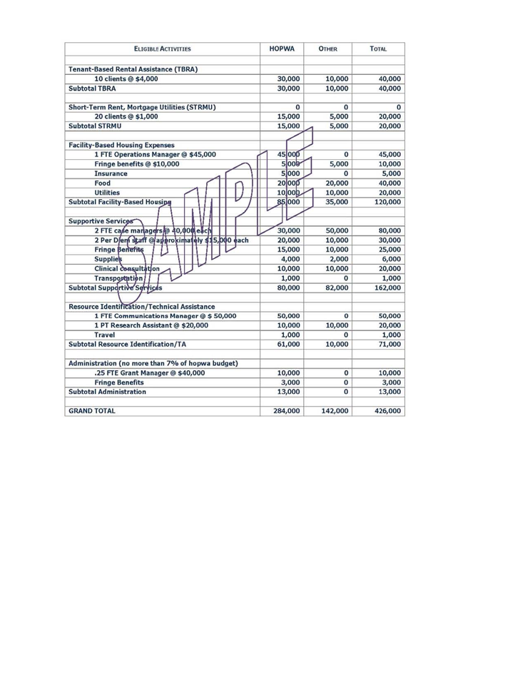

|  |  |  |  |
| --- | --- | --- | --- |
| **Eligible Activities** | **HOPWA** | **Other** | **Total** |
|  |  |  |  |
|  |  |  |  |
|  |  |  |  |
|  |  |  |  |
|  |  |  |  |
|  |  |  |  |
|  |  |  |  |
|  |  |  |  |
|  |  |  |  |
|  |  |  |  |
|  |  |  |  |
|  |  |  |  |
|  |  |  |  |
|  |  |  |  |
|  |  |  |  |
|  |  |  |  |
|  |  |  |  |
|  |  |  |  |
|  |  |  |  |
|  |  |  |  |
|  |  |  |  |
|  |  |  |  |
|  |  |  |  |
|  |  |  |  |
|  |  |  |  |
|  |  |  |  |
|  |  |  |  |
|  |  |  |  |
|  |  |  |  |
|  |  |  |  |
|  |  |  |  |
|  |  |  |  |
|  |  |  |  |
|  |  |  |  |
|  |  |  |  |
|  |  |  |  |
|  |  |  |  |
| **TOTAL** |  |  |  |