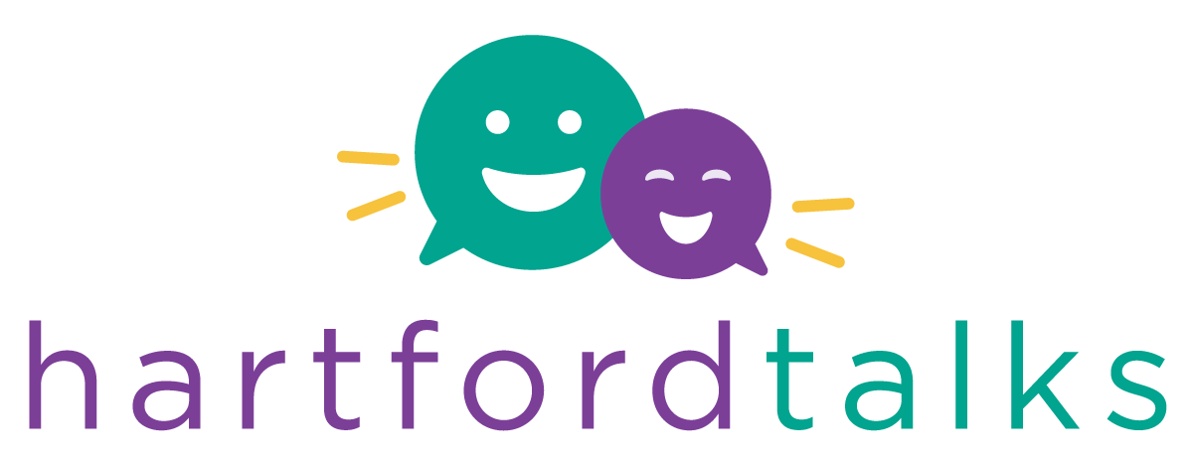
0
0

Implementation Application
Cohort 3
2021

This application includes questions that require your response, but also includes a great deal of information about Hartford Talks Implementation. Please read through all sections thoroughly. There is a lot of information that you need to consider before making a decision to apply.

The program uses unique “talk pedometer” technology to measure talk and interactions in the classroom to help educators provide a more language-rich and interactive classroom environment for our children.

With research continuing to highlight the importance of back and forth interactions between adults and young children to support brain growth and development, we want to make sure our teachers are providing the most language-rich environment possible for your child. At school, we will be incorporating 14 Talking Tips into our daily routines to increase the number of and quality of interactions throughout your child’s day.

Programs should identify a minimum of two classrooms with teachers who are willing to implement the evidence-based practices and participate in training.

Return the completed Application to: Katie.McGinnis@hartford.gov on or before January 15, 2021 For questions: Katie.McGinnis@hartford.gov

FREE CLASSROOM MATERIALS PROVIDED
LENA Grow implementation requires a significant commitment and takes time, effort and resources to be successful. This includes a significant commitment to attending virtual coaching sessions. All targeted staff in the building should watch the video https://www.youtube.com/watch?v=b94s7kot6hA to insure understanding of what LENA Grow entails. It will assist them in determining their readiness and commitment.

Readiness
Readiness to implement LENA Grow strategies and evidence-based practices.
- Staff agree to attend professional development and implement LENA Grow strategies
- The program commits to providing support to teaching staff
- Program Director agrees to engage families

Commitment
- Commit to a 3-9 month implementation plan
- Ensure teaching staff have the availability to meet one hour weekly with coach virtually for three months
- Program Director attends one meeting monthly for three months
- Provide support (financial or other) to allow staff to attend training
- Support families with consent documentation
- Work with Hartford Talks Coordinator to ensure fidelity
- 25 Hours of online professional development

LENA Start
Virtual Parenting Group

Do you want to support your program with virtual learning?

Hartford Talks- LENA Start is a virtual parenting program which provides new activities for parent to do at home with their children to week them engaged and improve kindergarten readiness skills. Books will be provided to families.

Would your program be interested in participating in a parenting group using LENA devices? Yes No

Program Demographics

Program Name:

Contact Name:

Title:

Email:

Phone Number:

Hours of Operation:

Number of Classrooms:

Number of Infant Classrooms: Number of Toddler Classrooms:

How many Classrooms would be implementing LENA Grow:

What data does your program currently collect and how is it shared with staff and families?

Literacy Supports and/or Curriculum
Please describe the program’s approach to enhancing the literacy development of young children though curriculum or other literacy initiatives.

Hartford Talks Implementation Timeline

What classroom materials does your program provide to support literacy in infant and toddler spaces?

Orientation Part 1: What, Why, and How?

Implementation Timeline

Orientation Part 1: What, Why, and How?

Orientation Part 2: LENA Day Logistics

Practice Day 1

Practice Day 2

Coaching Session 1: Introduction
Part 1: Introduction to Core Content
Part 2: Individual Coaching
Professional Development: Reflective Practices

LENA Day 3

Coaching Session 2: Effective Interactions
Understanding Room Detail Report
Meeting 1 with Program Director

LENA Day 4

Coaching Session 3: Environment and Routines

Program Director will observe LENA day 5 or 6 and complete checklist

LENA Day 5

Hartford Talks Coordinator will observe a coaching session between coaching session 4-7

Coaching Session 4: Active Learning

LENA Day 6

Coaching Session 5: Shared Reading
Midpoint Reflection

LENA Day 7

Coaching Session 6: Outdoor Experiences
Meeting 2 with Program Director

LENA Day 8

Coaching Session 7: Literacy through Lyrics

LENA Day 9

Coaching Session 8: Teachable Moments

LENA Day 10

Coaching Session 9: Positive Guidance

LENA Day 11

Coaching Session 10: Celebration
Meeting 3 with Program Director

Refresher Sessions: 3 to 6 months after Coaching Session 10
Week 1: Refresher Meeting
LENA Day 1
Week 2: LENA Day 2
Week 3: LENA Day 3
Week 4: Refresher Data Review

