Office of Energy Efficient Businesses
City of Hartford Report
January 7, 2015

Introduction:
The Office of Energy Efficient Businesses (OEEB) provided energy outreach services to businesses within the City of Hartford, in cooperation with and support from the Mayor’s office. Prior to undertaking outreach in the City of Hartford, OEEB identified, analyzed, and mapped all businesses within the City (see Figure 1). In addition, OEEB developed a baseline energy assessment for the City of Hartford that identified the energy efficiency potential, including electricity and thermal energy. A summary is presented below in Table 1.

Table 1 – Electric and thermal energy consumption within the City of Hartford

 | Energy Consumption Estimates | .5% of Annual Load | 1% of Annual Load | 2% of Annual Load | 10% of Annual Load
Aggregate Electricity Consumption (kWh/year) | 1,836,408,414 | 9,182,042 | 18,364,084 | 36,728,168 | 183,640,84
Aggregate Thermal Energy Consumption (MMBTUs/year) | 5,884,270 | 29,421 | 58,843 | 117,685 | 588,427

Outreach:
OEEB met with the Mayor’s Office, the chief elected official, representatives from the municipality (economic development director, energy office, etc.), Connecticut Department of Energy and Environmental Protection (DEEP), Clean Energy Finance and Investment Authority (CEFIA), United States Department of Energy (DOE), Energy Conservation programs managed by Connecticut’s investor owned utilities, and neighborhood associations during outreach to businesses within Hartford. OEEB energy outreach specialists also met with community groups and merchant associations (see Appendix 3). In addition, OEEB distributed a support letter provided by Mayor’s Pedro E. Segarra to businesses in the City (see Appendix 1). The OEEB energy outreach specialists canvassed businesses identifying opportunities to help businesses save money and reduce energy consumption, including upgrades in lighting and HVAC appliances, fuel conversions, and showed local business owners methods to competitively shop for electric suppliers.
The OEEB energy outreach specialists visited 2,417 businesses in the City of Hartford. As shown in Table 2, OEEB directly assisted 333 businesses on how to read their energy bill to determine if a third party supplier’s rate is more competitive, and conducted energy assessments for 130 businesses that entailed OEEB staff taking an inventory of the business’ energy usage and determining how much energy can be saved through energy efficiency measures. Of the 130 businesses assessed, 35 businesses had significant savings and were referred to EnergizeCT programs, such as the Small Business Energy Advantage (SBEA) program; 33 businesses had “do it yourself” projects where each business was given information on corresponding EnergizeCT energy efficiency rebates (see Appendix 2); 23 businesses did not have sufficient savings to warrant further action, and 39 businesses did not want to be referred. There were three businesses, not included in the 130, that were referred to a utility program but did not receive an energy assessment from OEEB because two businesses were referred to the Energy Conscious Blueprint program for a building envelope analysis and one business was referred to the Home Energy Solution program. The referred projects included upgrading inefficient lighting systems, switching from oil burning boilers to natural gas units, and upgrading to higher seasonal energy efficiency ratio (SEER) rated air conditioning units.
In Hartford, 1,572 businesses did not take advantage of the free services offered through OEEB, for a variety of reasons, including 1) businesses were corporate-owned, 2) the energy bills were not paid directly by the businesses, 3) business owners were already working with energy efficiency programs, or 4) business owners were not interested. It should also be noted that 431 businesses were closed with no occupancy and 281 businesses were home-based, and therefore, ineligible for OEEB’s assistance.
SBEA’s approved contractors worked with the businesses to develop proposals and complete efficiency upgrades. After each proposal is completed, business owners elect whether or not to continue with the project, which can be funded partially through state rebates and/or a low interest loan on their energy bill.

Table 2 – Summary of Outreach Activity (March 2013-October 2014)

Total Businesses Visited | 2,417
- Non-Assessed Energize CT Program Referrals | 3
- Assessments Completed | 130
- Program Referrals | 68
- Do It Yourself Customer (DIY) | 33
- Energize CT Programs | 35
- No available cost savings found | 23
- Report Delivered/Not interested in Referral | 39
- Supplier Education Provided | 333

Outcomes:
It has been calculated that the identified energy efficiency measures in the City of Hartford would save approximately:
- 527,919 kWh/year;
- $349,617 in energy costs lifetime (energy efficiency measures);*
- $23,804 in energy costs annual (from third-party supplier education);
- $153,392 lifetime from switching from oil to cleaner-burning and more economical natural gas;*
- 7,182,346 pounds of CO2 (lifetime)
While the savings do not meet the targets established by OEEB for the City of Hartford, these savings are significant as a first step by OEEB for underserved businesses in the City of Hartford to reduce energy demand and improve environmental performance.
Examples of Outreach Results:
Hartford Stage Company, 50 Church Street, Hartford CT
Hartford Stage Company is one of the leading resident theatres in the United States, and has earned many of the nation’s most distinguished awards. OEEB conducted a detailed facility study and identified cost savings for the Hartford Stage company’s lighting systems and energy procurement practices totaling approximately $6,900 per year. OEEB subsequently referred Hartford Stage to the EnergizeCT Small Business Energy Advantage (SBEA) program, which identified an additional $2,800 per year in savings from energy efficiency upgrades. Energy efficiency work was subsequently completed by electric contractors in January 2014. Hartford Stage received $13,800 in incentives from the SBEA program towards its project. In addition, Hartford Stage is estimated to realize almost $4,700 in cost savings from changing electric suppliers.
Aladdin Halal Restaurant and Pizzeria, 121 Allyn Street, Hartford CT
Aladdin Halal Restaurant and Pizzeria is a Mediterranean restaurant located in downtown Hartford. OEEB identified opportunities to reduce costs through the use of newer, more reliable, energy efficient lighting. OEEB referred Aladdin to the EnergizeCT Small Business Energy Advantage (SBEA) program. The total cost of the project work was estimated at $3,000 and the SBEA program provided $1,800 in eligible rebates towards the project. The project is estimated to have a payback in 2-3 years.
Spiritus Wines, 220 Asylum Street, Hartford CT
Spiritus Wines is a retailer of fine wines, liquors, and beers located on Asylum Street in Hartford. OEEB identified opportunities to reduce costs through the use of energy efficient light-emitting diode (LED) lighting, and refrigeration technologies. OEEB referred Spiritus Wines to the EnergizeCT Small Business Energy Advantage (SBEA) program. The total cost of the project work was estimated at $12,665, and the SBEA program provided $5,955 in eligible rebates towards the project.
Mr. Pizza House, 671 Blue Hills Ave, Hartford CT
Mr. Pizza House is a fast food restaurant located on Blue Hills Avenue in Hartford. OEEB identified opportunities for replacement of Mr. Pizza House restaurant’s lighting and HVAC systems. OEEB referred Mr. Pizza House to CL&P’s building envelope program through Small Business Energy Advantage (SBEA) program. The total cost of the project work was estimated at $10,000 and the SBEA program provided $4,500 in eligible rebates towards the project.
Conclusion:
Although outreach has finished in Hartford, OEEB will continue to support and guide businesses through the referral process to implement efficiency measures. Since the projects take several months to complete, OEEB staff will maintain relationships as needed with business owners and continue to be an unbiased resource throughout the entire process. The City of Hartford will continue to see benefits into the future as energy cost are reduced, freeing up capital for investment back into their business and the community.

Figure 1 – City of Hartford Businesses – Route Map
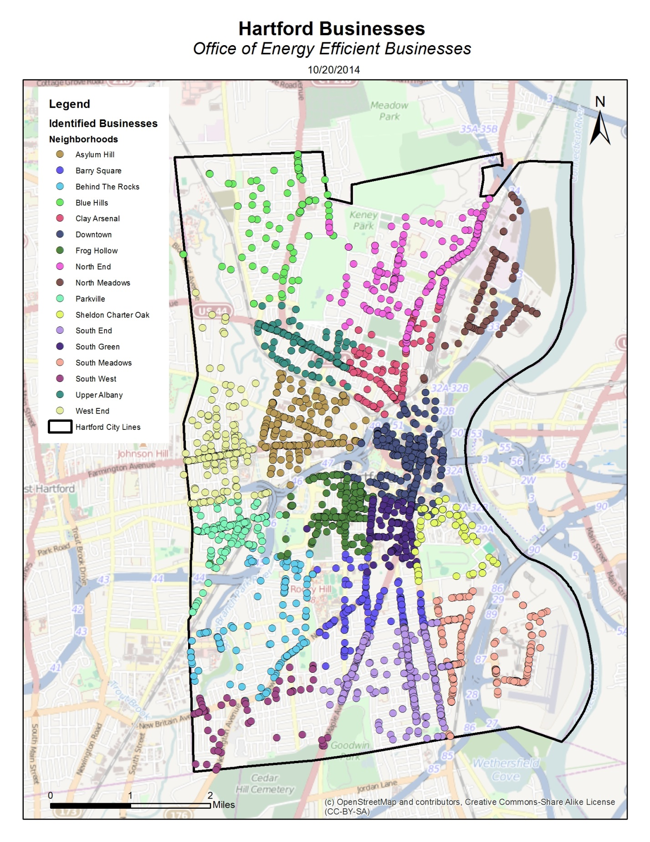
Appendix 1-Mayor Pedro E. Segarra Letter of Support
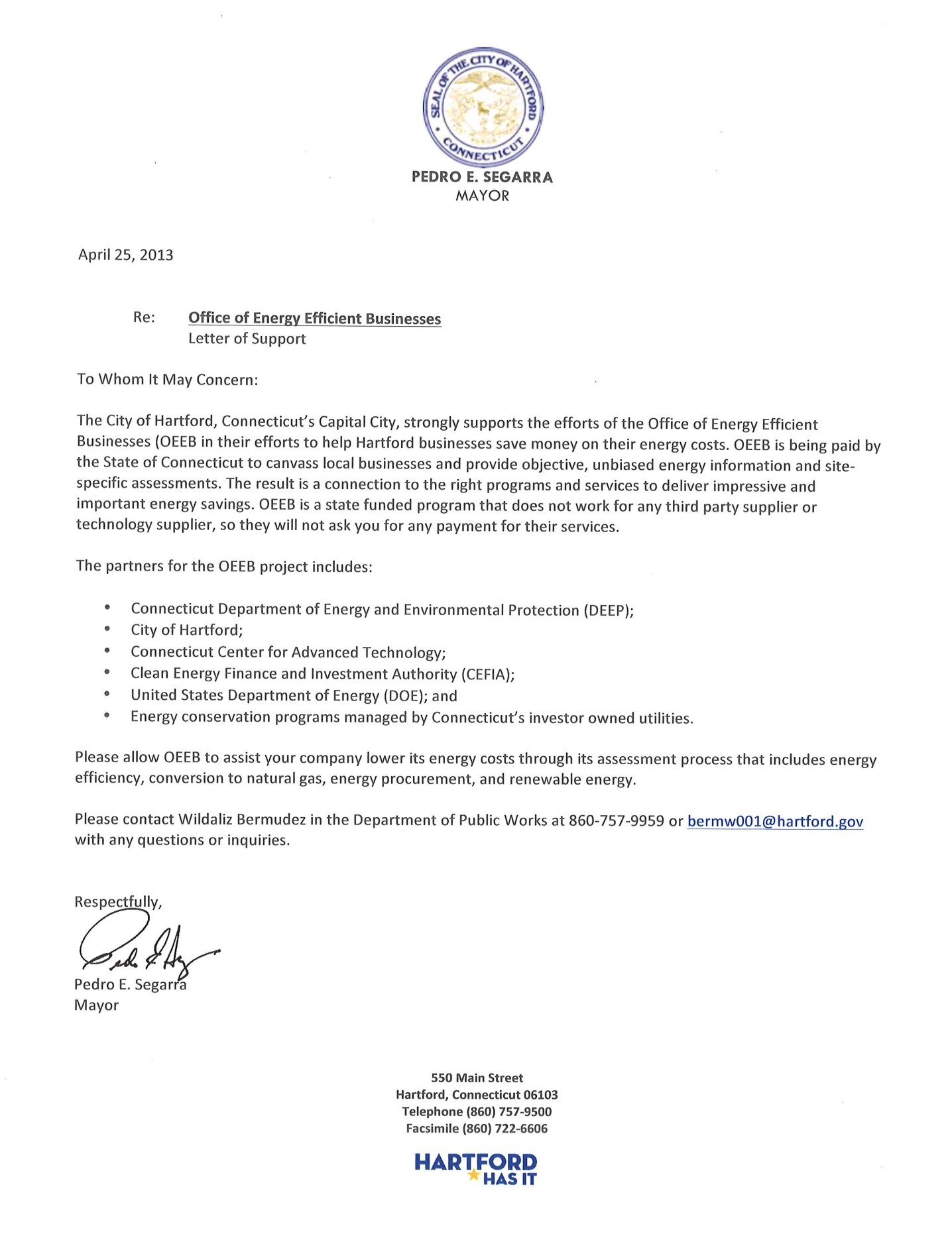
Appendix 2-Referral List
OEEB Business Referral List
(EnergizeCT Programs / Do It Yourself)
Aladdin Halal Restaurant | Ipanema Café
Allegro Café | J & D Performance LLC
Ariel Market | J's Crab Shack
Bacon Antiques | King and I Thai Res.
Baltyk European Deli | La Kerencya
Bazzano & Rosenbloom | Marconi Development Corp
Bravo Supermarket | Main Street Insurance
Capitol View Deli | Max Bibo's
Caribe Restaurant | Max Downtown
Carter Reality | Metal Industries, Inc.
Center Stage Hair Salon and Spa | Mr. Pizza
City Steam Brewery Café and Restaurant | New Mercury Cleaners & Tailors
Charities of Hope Inc. | Nutmeg Planners
Color Copy Ctr. | Percy's Auto Shop
Davanty Salon & Barber | Property Shop of CT
De Vars - Phillips Florist & Antiques | Reardon’s Color Center
Comerio | Rapienvio
DiFiore Pasta Company | Rosetta Hair Styling
Divina's | S& L Management
D'Mary Ann Grocery | Salute
El Kiosko LLC | Salvin Shoe Store Inc.
EL Nuevo Amanecer Restaurant | Signature Gold Jewelry
European Grocery | Silvestor Space Services
Fantasia Hair Design | Spiritus Wines
Federal Café | Storage City
Fidas Mini Market | Su Seguro
Franklin Foundation DDS | Sully's Pub
Fred's Dry Cleaners | Supreme Cuts
Hartford Business Journal | Taxes & Real Estate Services
Hartford Community Loan Fund | The Tobacco Shop
Hartford Psychological Services | TheaterWorks
Hartford Stage Company | Tinker Realty & Insurance
Heavenly Angels Beauty Salon | Trinity Tap Sports Bar
Heip Phat Restaurant | Vista Alegre
Hip Stop Clothing | We Care Family Dental Center
Hot Tomato's Ristorante | Windsor Street Auto Body
Appendix 3-Community & Merchants Associations
OEEB Community & Merchants Associations
Asylum Hill Neighborhood Association
Bauza &Associates
Blue Hills NRZ
Business for Downtown Hartford and Hartford Business Improvement District Executive
Capital Workforce Partners
Connecticut Coalition of Mutual Assistance Associations (CCMAA)
Connecticut Restaurant Association (CRA)
CT Soar Program
Farmington Asylum Business District
Farmington Avenue Alliance
Franklin Avenue Merchants Association (FAMA)
GHYMCA
Greater Hartford Score
Greater New England Supplier Development Council (GNEMSDC)
Hartford 2000
Hartford Areas Rally Together (HART, Inc.)
Hartford CTWorks Center
Hire Vets First
Job Corps
Latino and Puerto Rican Affairs Commission
Maple Avenue Revitalization Group (MARG)
MetroHartford Alliance
NAACP Greater Hartford
North Star Center for Human Development
Northside Institutions Neighborhood Alliance (NINA)
Operation Fuel (BEST)
Parkville Revitalization Association (PRA)
Small Business Administration
South Hartford Business Alliance
South Meadows Market Alliance (SMMA)
Southend Neighborhood Revitalization Association
Southside Institutions Neighborhood Alliance (SINA)
Upper Albany Avenue
Urban League of Hartford
Women Business Center- Director of Hartford Branch

Acknowledgment: “This material is based upon work supported by the U.S. Department of Energy and Connecticut’s Department of Energy and Environmental Protection under Award Number(s) DE-EE0005301. Funding provided by the U.S. Department of Energy; administered by the Connecticut Department of Energy and Environmental Protection”
Disclaimer: “This report was prepared as an account of work sponsored by an agency of the United States Government. Neither the United States Government nor any agency thereof, nor any of their employees, makes any warranty, express or implied, or assumes any legal liability of responsibility for the accuracy, completeness, or usefulness of any information, apparatus, product, or process disclosed, or represents that its use would not infringe privately owned rights. Reference herein to any specific commercial product, process, or service by trade name, trademark, manufacturer, or otherwise does not necessarily constitute or imply its endorsement, recommendation, or favoring by the United States Government or any agency thereof. The views and opinions of authors expressed herein do not necessarily state or reflect those of the United States Government or any agency thereof.”

Annual aggregate kWh calculated using Total Electric Energy Intensity coefficient (12.4 kWh/sqft) for the Northeast Census Region. Commercial Buildings Energy Consumption Survey: Table E6A. Electricity Consumption (kWh) Intensities by End Use for All Buildings, 2003.
Annual thermal energy calculated using Total Natural Gas Intensity coefficient (44.1 cubic feet/sqft) for the Northeast Census Region. Commercial Buildings Energy Consumption Survey: Table E8A. Natural Gas Consumption (cubic feet) and Energy Intensities by End Use for All Buildings, 2003
*Cost savings calculated in present value terms, assuming a 7% discount rate and a 15 year analysis window ⁴ ISO New England Electric Generator Air Emissions Report, http://www.iso-ne.com/genrtion_resrcs/reports/emission/2011_emissions_report.pdf; (based on 15 year term)

